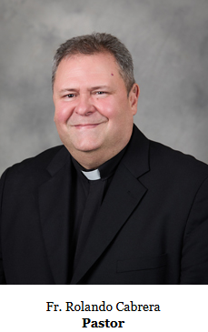
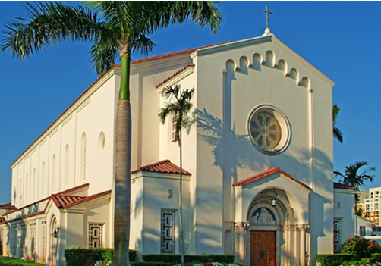

ST. ANTHONY
CATHOLIC COMMUNITY. FTL
PASTOR’S MESSAGE

July 12th, 2026

15th Sunday in Ordinary Time
Year A

Dear Parish Family,

This Sunday’s Gospel presents us with a beautiful parable of the sower.

God is the generous sower who never tires of scattering the seed of His Word. He does not reserve His blessings for a select few but offers His love, mercy, and truth to everyone. The difference is not in the seed-it is always good-but in the condition of the soil that receives it.

Summer often gives us a little more time to slow down, rest, and reflect. It is a wonderful opportunity to cultivate the soil of our hearts through prayer, the Eucharist, the Sacrament of Reconciliation, and acts of charity. The more we allow God’s grace to remove the rocks of resentment, the thorns of worry, and the hardness of indifference, the more fruit our lives will bear.

As a parish family, may we continue to be fertile soil where faith grows, hope is renewed, and love is shared. Let us welcome God’s Word with open hearts and put it into practice in our homes, our workplaces, and our community.

May the Lord bless you and your loved ones with a joyful and peaceful week.

Fr. Rolando

