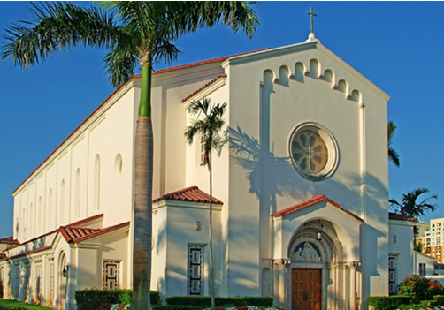
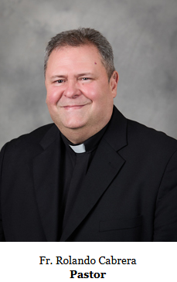

ST. ANTHONY
CATHOLIC COMMUNITY. FTL
PASTOR’S MESSAGE

July 5th, 2026

14th Sunday in Ordinary Time
Year A

Dear Parish Family,

This weekend, as we celebrate Independence Day and begin the commemoration of the 250th anniversary of the United States, we give thanks to God for the many blessings of living in a nation founded on the ideals of freedom and human dignity.

In this Sunday's Gospel, Jesus extends a beautiful invitation: "Come to me, all you who labor and are burdened, and I will give you rest." True freedom is found not only in political liberty but also in the peace that comes from walking with Christ. He frees us from sin, fear, resentment, and despair, and teaches us that humility, love, and service are the path to lasting joy.

As we thank God for the blessings of our country, let us also remember with gratitude all those who have sacrificed to preserve our freedoms. May we never take for granted the precious gift of religious liberty, which allows us to gather in worship, proclaim our faith openly, and serve our neighbors in Christ's name.

This anniversary is an opportunity to renew our commitment to building a nation marked by justice, compassion, respect for the dignity of every human person, and care for the common good. As Christians, we are called to be faithful citizens who bring the light of the Gospel into our families, our workplaces, our communities, and our nation.

May the Lord continue to bless our parish family, bless the United States of America, and help us use the gift of freedom to love God and serve one another.

Happy Independence Day! May God bless you and your loved ones.

Fr. Rolando

